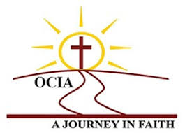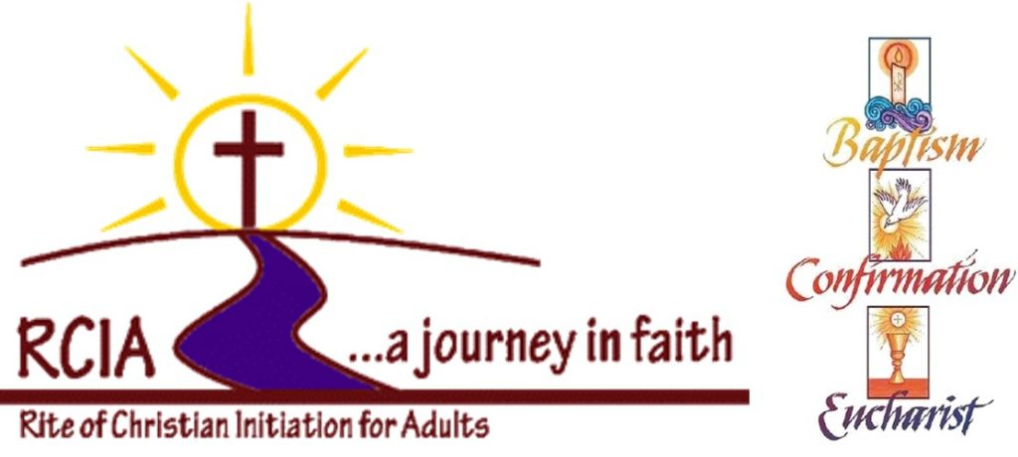 **Are you considering**

**the Catholic faith?**

*"When you look to me, you will find me. Yes, when you seek me with all your heart.” (Jeremiah 29:13)*

# Are you thinking about becoming Catholic?

# ***“The Lord waits for you to come to him, so he can show you his love and compassion. For the Lord is a faithful God.”*****Isaiah 30:18**

#### **Responding to God’s Call**

#### No matter when you begin to consider Catholicism, rest assured that God is present from the first moment of your spiritual journey. As you begin to feel a tugging at your heart or the call of “the still small voice within,” God is there. In your questions and desire to know more, God is there. There are many reasons you may yearn to deepen your relationship with God.

At times, it is through the practice of the faith that we observe in friends, coworkers, or spouses. At other times, it is through independent inquiry — whether that is in the form of more academic study of religions, or simply attending a Catholic Church and being drawn to a certain community.

We welcome you and want to walk with you as you prayerfully consider where God is leading you. Below are ideas to help you hear God’s voice and suggestions on next steps should you decide to take a step in learning more about the Catholic faith.

Catholic parishes offer inquiry sessions that allow seekers to examine the Catholic faith more closely. During these sessions participants ask questions, explore Catholic teachings and discover what it means to be a Catholic Christian. These sessions are designed to offer accurate information and clarify any misconceptions about the Catholic Church. If participants feel the desire to become Catholic, they may move into a deeper level of faith formation that focuses on prayer, sharing, community and reflection called the Order of Christian Initiation for Adults (OCIA).

#### **OCIA: the process for becoming Catholic**

The Order of Christian Initiation of Adults (previously called the Rite of Christian Initiation of Adults) is a series of steps (formal rites) conducted in the context of learning about the faith and spiritual formation, through which a person is fully incorporated in the Body of Christ, the Church. There is no set length of time that it takes to become Catholic.  The decision to become fully incorporated into the Church is left to the individual and must come from the depths of the heart and soul. The Church makes clear that what is important is not meeting a schedule, but instead ensuring adequate preparation to receive the Sacraments of Initiation (Baptism, Confirmation and Eucharist.

The **Four Phases of the Order of Christian Initiation of Adults**. There are 4 phases or stages in the Church's process of preparation to enter the Church through baptism or by being received into full communion: Inquiry, the Catechumenate, Purification and Enlightenment, and Mystagogy.

***Sponsors***

A Sponsor accompanies any person seeking full initiation into the Catholic Church. a) Both unbaptized catechumens and baptized catechumens need to have a sponsor.

b) The Sponsor should be over 16 years of age and a practicing and respectable Catholic to accompany the catechumen or candidate at catechetical sessions, all rites, and other RCIA events (e.g., retreats).

***Where to Begin?***

Begin with prayer for guidance; ask questions (*“Ask and it will be given to you; seek and you will find; knock and the door will be opened to you.” Mt. 7:7);* and talk with a pastor or a staff member at a local Catholic Church to help you explore the Catholic faith and answer your questions about the OCIA process.

***What if I have never been baptized?***

If you have never been baptized, you prepare for the catechumenate. This process includes several stages marked by study, prayer and rites at Mass. The catechumens undergo a process of conversion as they study the Gospel, profess faith in Jesus and the Catholic Church, and receive the sacraments of baptism, confirmation and Holy Eucharist at the Easter Vigil.

***What if I have been baptized in another Protestant faith?***

If you are baptized in another Christian tradition, you prepare as prospective candidate for full communion. This initiation process prepares the candidate to enter into full communion with the Catholic Church by celebrating the sacraments of Confirmation and Holy Eucharist.

#### **Becoming Catholic**

Becoming Catholic is a spiritual adventure that believers have traveled for more than 2,000 years. But no one should embark on the journey without considerable thought, prayer and reflection. Other people can offer information and advice, but, ultimately, you have to make the decision for yourself. Whatever you decide, you can be sure that God is with you on your spiritual journey.

***What is the next step?***

***1)*** Fill out an OCIA Registration Form; ***2)*** Schedule a meeting with Deacon Chuck and Linda Cooper to discuss any questions on the form and find out when classes will begin. Remember, no question is too small or too big and some may come from misconceptions or wrong conclusions based on faulty thinking, wrong facts or failure to understand. ***3)*** Classes are held once a week in the evening for a couple of hours and attendance is mandatory and essential for learning the richness of the Catholic faith *and tradition* which have a depth and breadth that needs to be explained and experienced.

**Other Resources:**

***The RCIA Journey – A Resource for the Catechumenate***

***Catechism of the Catholic Church -*** contains a full description of the tenets of Catholicism

***Alan Schreck’s The Essential Catholic Catechism*** – gives you a first-class grounding in the Catholic faith; covers and explains all the necessary tenets of Catholicism.

***Leo Trese’s The Faith Explained*** – explains the basics of the faith in a better and more memorable way.

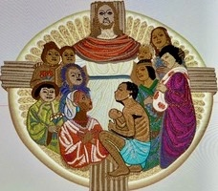

*St. Gerard’s Catholic Church - Order of Christian Initiation of Adults*

*Pastor Rev. Emmanuel Andinam*

*Deacon Dr. Chuck Cooper*

*Parish Office: 803-649-3203*

OCIA Registration Forms available by calling the Parish Office – can be emailed for your convenience or available in the back of church.